Skyline Ion Mobility Spectrum Filtering
In this tutorial, you will learn how data from a simple mixture can be used to create ion mobility libraries for use in ion mobility separation (IMS) with more complex samples. By first training with a simple data set, in this case bovine serum albumin (BSA) spiked into water, ion mobility and collision cross section values can be added to a Skyline document. The stored ion mobility for a given precursor can be used to increase the selectivity of precursor and fragment extracted ion chromatograms above what can be realized by high mass resolution alone, thereby reducing interference from other ions.
In this more advanced tutorial, some familiarity with Skyline is assumed. If you are not familiar with Skyline, you should first work through some of the introductory tutorials at
http://skyline.ms/tutorials.url

Getting Started
To start this tutorial, download the ZIP file at:
http://skyline.ms/tutorials/IMSFiltering.zip
Extract the files in it to a folder on your computer, like:
C:\Users\bspratt\Documents
This will create a new folder:
C:\Users\bspratt\Documents\IMSFiltering
This folder will contain the Skyline files necessary for this tutorial. In addition to these files, you will need to download two Agilent mass spec raw data files from the following links:
http://skyline.ms/tutorials/data-drift/BSA_Frag_100nM_18May15_Fir_15-04-02.d.zip
http://skyline.ms/tutorials/data-drift/Yeast_0pt1ug_BSA_100nM_18May15_Fir_15-04-01.d.zip
This is a total of nearly 5GB of data, so download may take a while. Once downloaded, unzip the .d files to your previously created “Documents\IMSFiltering“ folder so that it contains subfolders named BSA_Frag_100nM_18May15_Fir_15-04-02.d and Yeast_0pt1ug_BSA_50nM_18May15_Fir_15-04-01.d. Note that while these are referred to as files in this tutorial, they are technically folders.
The file BSA_Frag_100nM_18May15_Fir_15-04-02.d contains the raw data from a tryptic digest of BSA standard mix in water, which should make a clean training set for BSA peptide drift times. The file Yeast_0pt1ug_BSA_100nM_18May15_Fir_15-04-01.d contains the raw data from a sample of the BSA standard mix and spiked into a yeast cell lysate background.
Both files contain ion mobility information. In this example, ion mobility is expressed in terms of drift time but the concepts can be generalized to other ion mobility types such as inverse reduced ion mobility.
Also note that while this tutorial is in terms of peptides, like most things in Skyline these principles are equally applicable to small molecule targets.

Start Skyline and Open the Example Skyline Document
If you are not already running Skyline, start it now.
- On the File menu, click Open (ctrl-O).
- Select BSA-Training.sky in your newly created IMSFiltering folder.
- Click the Open button.
The document has no mass spec results loaded yet, and looks like this:
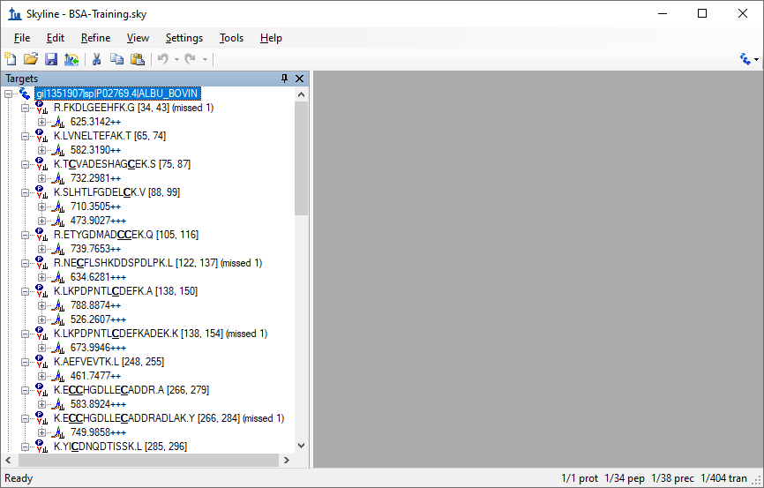
This document is the result of importing a peptide search that included a BSA digest. It is set up for full gradient chromatogram extraction and at this point does not have any Ion Mobility information. It is probably worth reviewing the transition settings:
- On the Settings menu, click Transition Settings.
- Review the Filter, Library, Instrument, and Full-Scan tabs.
The Full-Scan tab is especially worth reviewing any time you are importing non-SRM data, and it should look like this:
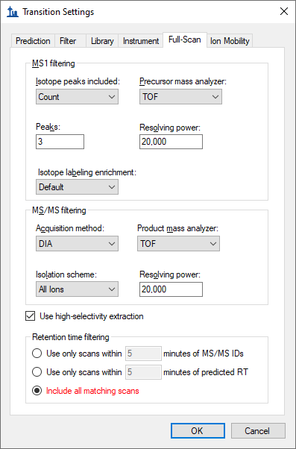
This instructs Skyline to extract 3 precursor isotope peaks from MS1 (low-energy) spectra and fragment ions from MS/MS (high energy) spectra acquired at 20,000 resolving power on a TOF instrument. The acquisition method “DIA” and isolation scheme “All Ions” are what tell Skyline the spectra will be alternating low- and high-energy without precursor isolation. When Use high-selectivity extraction is checked, Skyline extracts a single resolution width around the target m/z, and when it is unchecked Skyline extracts 2x the resolution width, which should increase the total number of ions included in the extraction at the risk increasing interference.
Finally, the Include all matching scans option tells Skyline to extract full-gradient chromatograms, which is not usually desirable, but in both the retention time and drift time dimensions we do not yet have enough information to narrow the range we want to consider for the target ions. But, with one of the samples being a BSA standard mix injected into water, you can be reasonably sure of finding the ions of interest and training Skyline to restrict the range of consideration in a more complex sample. If the initial spectral library document was created under the same chromatographic conditions as the ion mobility data sets, the retention time can be included.

Import the Results Data
In this section, you will import both the training data and the mixture data. Initially, this is just to look at the mixture data to see the impact of interference among the targeted peptides and the yeast background in the mix. We will load the training and mixture data simultaneously just to save time, since Skyline can load the two in parallel.
- From the File menu, choose Import and click Results
Which should bring up the Import Results form:
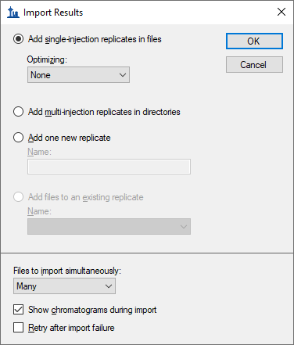
- Set the File to import simultaneous field to “Many”.
- Check Show chromatograms during import.
- Click the OK button.
The Import Results Files form should appear as below, showing the .d files you have extracted into the tutorial folder:
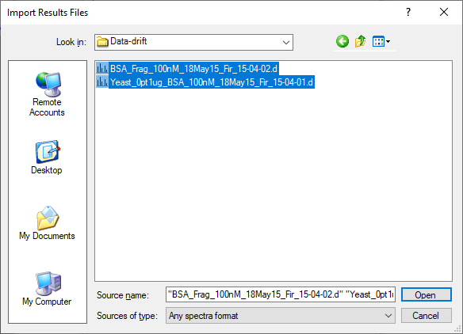
- Select both .d files.
- Click the Open button.
This should start the import and cause Skyline to show the Importing Results progress form:
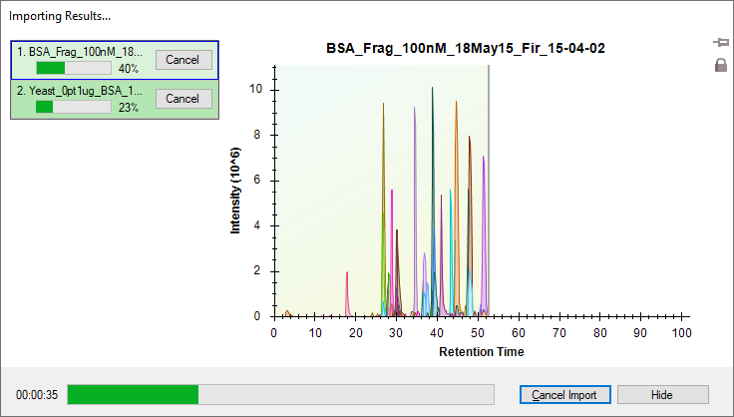

Reviewing the Extracted Ion Chromatograms
Once the files are imported, you can examine the mixture alongside the simple data set and compare the amount of interference you can see in each.
- From the View menu, choose Arrange Graphs and click Tiled (Ctrl-T).
- From the View menu, choose Auto Zoom and click Best Peak (F11).
- From the View menu, choose Transitions and click Split Graph. (leave if already checked)
- Select the first peptide “R.FKDLGEEHFK.G [34, 43] (missed 1)”
Already, it is easy to see that even though both samples had the BSA standard mix injected at the same concentration, the sample with the yeast background shows more evidence of interference, with more peaks at other retention times than the obvious one that Skyline chose. Also, the y8 ion appears more intense in the yeast background sample:
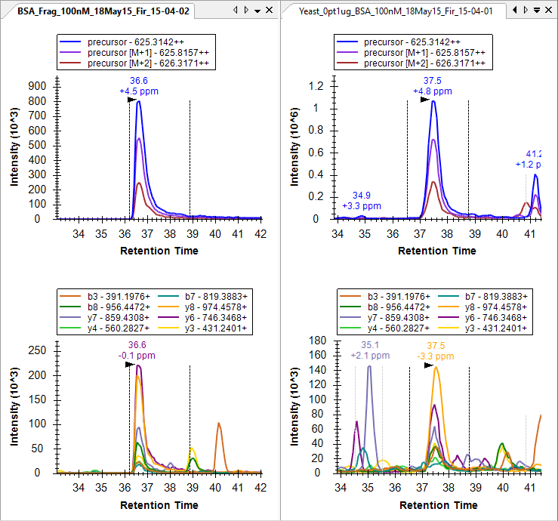
The difference is even more pronounced, if you view the entire gradient range by doing the following:
- On the View menu, choose Auto-Zoom and click None (shift-F11).
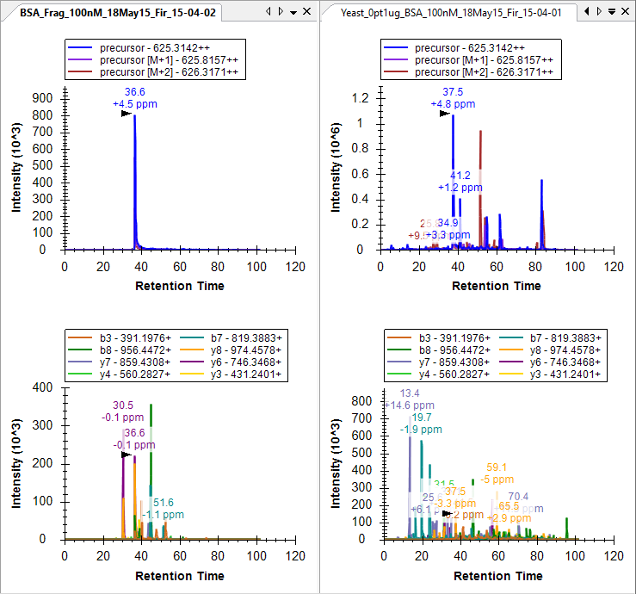
Since there are only 38 peptide precursors in this document, you may want to review all 38 to get an overall feel for how the extracted ion chromatograms differ between the two, maybe even both zoomed to the best peak and then quickly with the chromatogram graphs un-zoomed. Before starting this review, do the following:
- On the View menu, choose Auto-Zoom and click Best Peak (F11).
- On the View menu, choose Retention Times and click Replicate Comparison (F8).
- If the water sample (BSA_) appears after the yeast sample in this summary plot,
right-click the Retention Times graph, choose Order By and click Document.
- Attach the Retention Times view to the right edge of the Skyline window by clicking in the title bar and dragging until the mouse cursor is inside the right-side docking icon.
- On the View menu, choose Peak Areas and click Replicate Comparison (F7).
- Attach the Peak Areas view to the right edge with the Retention Times view.
- Right-click in the Peak Areas view and click Legend to hide the legend in its graph.
- Right-click in the Peak Areas view, choose Normalize To and click Total.
- Right-click in a chromatogram graph and click Legend to hide the legend in those graphs.
- Right-click in a chromatogram graph and click Synchronize Zooming. (leave if already checked)
You should end up with a layout that looks something like this:
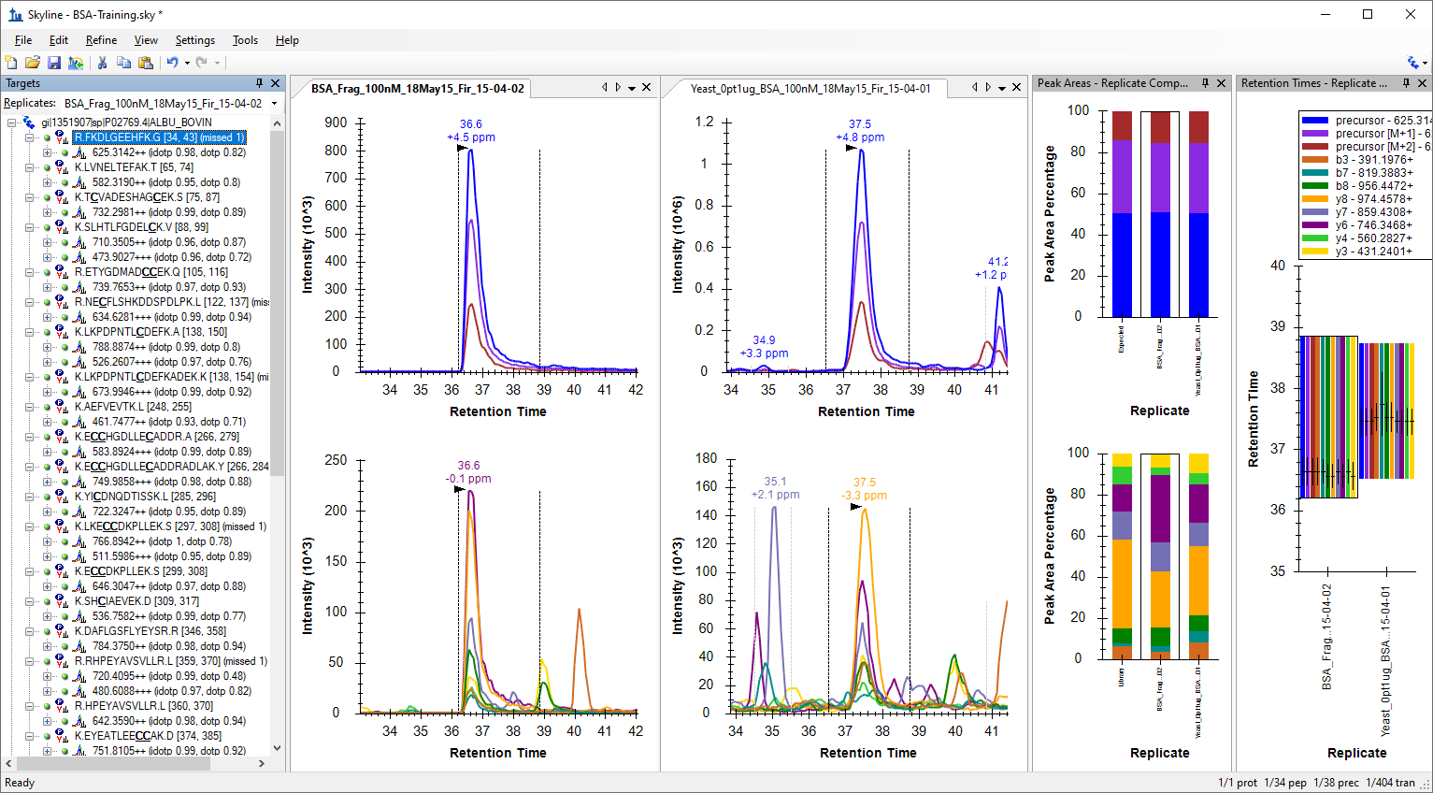
This will help make it obvious how the retention times in the two replicates compare with each other. As you review, you should become accustomed to seeing the peptides in the yeast sample eluting about 1 minute later than they elute in the water sample. When this is not the case, there is usually something worth looking at. There are four noteworthy cases in this document, two near the top and two near the bottom. See if you can find them all.
When you find a case where the time do not match the expected pattern of yeast eluting 1 minute later than water, you can do the following:
- Click in the water chromatogram graph (left side) and use the mouse or touchpad to scroll slightly (using a scroll-wheel or two-fingers respectively).
The most extreme case you will find is the third peptide TCVADESHAGCEK where Skyline picks a peak at 3.3 minutes in water and 70 minutes in yeast. When you zoom to 3 minutes in yeast, you will find that there is really nothing there for Skyline to pick, and this earliest eluting peptide was lost in the chromatography for the yeast sample.
Make a note of this for your future processing. It turns out this peptide was lost in all of the yeast samples in the dilution series you are working with.
- Right-click on the peptide in the Targets view and click Edit Note.
- In the Note field, type “Lost in yeast samples”.
The form should look like this:
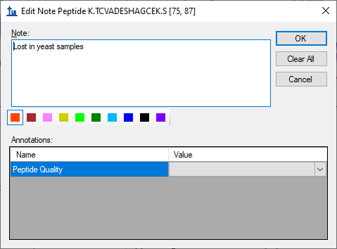
- Click the OK button.
The sixth peptide (seventh precursor) NECFLSHKDDSPDLPK is the other problem peptide near the top of the Targets list. If you watch the apex lines closely in the Retention Times plot, you will notice that the peak Skyline picked elutes earlier in yeast than water. Or, in the chromatogram plots, you will see that the peak lacks a convincing precursor peak.
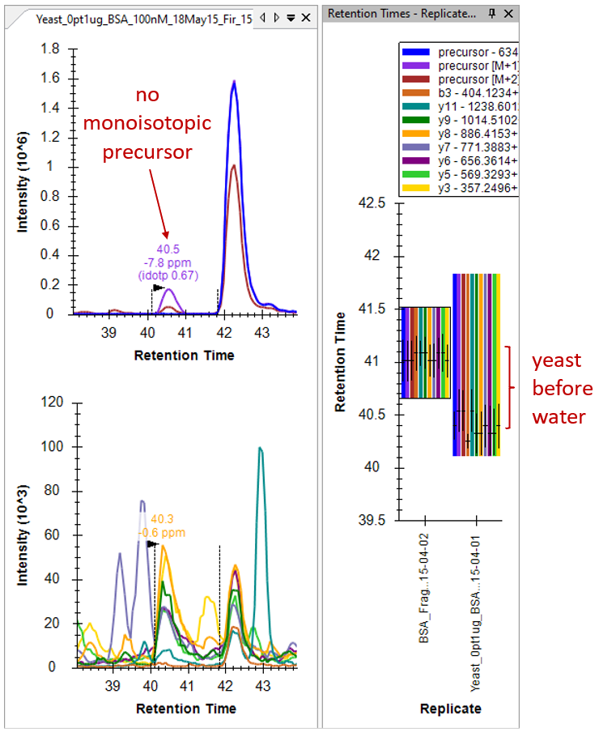

Understanding Ion Mobility Separation
To better understand what is going on here, it Is time to introduce the new ion mobility dimension in this data, which we have so far ignored. To do that, you need to look at the underlying spectra from which these chromatograms were extracted, by doing the following:
- Hover the mouse cursor over the water (left side) precursor chromatogram peak apex until a blue or purple circle appears that tracks the mouse movement, and click on it.
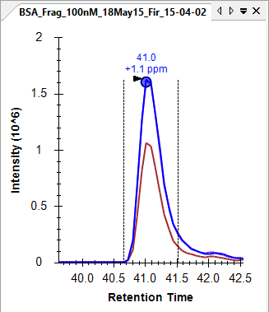
This should bring up the Full-Scan view showing a normal two-dimensional spectrum in profile mode:
- Click the Show 2D Spectrum button to change the plot to a 3D spectrum with drift time.
You can see that only one peptide precursor is visible in this plot at 634.6 m/z and 25 ms drift time.
- Click the Zoom to Selection button to see the entire 3D MS1 spectrum.
This is a typical MS1 spectrum for IM-MS data, with separate distributions of ions showing correlation between m/z and drift time for separate charge states. A higher slope in the distribution indicates a lower charge state. You can convince yourself of this using the plot navigation features available in all Skyline graphs.
- Place the cursor over an area of interest and use mouse-centered zooming to zoom in.
- If points start to separate too much in the y-dimension, move the cursor below the x-axis and continue using mouse centered zooming to inspect the isotope distribution of a feature.
You will see that features in the upper distribution have isotopes separated by 1 m/z, while It is possible to find charge 4 and even 5 ions in this spectrum.
To inspect a relevant MS/MS spectrum do the following:
- Click on the Zoom to Selection button again to zoom back in.
- Hover the mouse cursor over the water (left side) y8 fragment chromatogram peak apex until a mustard colored circle appears that tracks the mouse movement, and click on it.
The Full-Scan graph should change to look like this:
You can see the most intense visible ion is also at 25 msec, consistent with its precursor, with 1 m/z isotope spacing, consistent with the expectation of a singly-charge y8 ion. but even in water there are probably at least 2 other ions visible at 30 and 40 ms contributing to the extracted intensity. The singly charged ion at 40 ms appears to line up very closely with the ion of interest, and might be the same y8 ion contributed by a lower charge state of the peptide. The ion at 30 ms, however, may have a lighter monoisotopic peak and with 0.5 m/z isotopic spacing is clearly at doubly charged fragment ion.
- Click the Zoom to Selection button again to see the entire 3D MS/MS spectrum.
This is also a typical MS/MS spectrum, where you can imagine each horizontal stripe as a top-down view of a normal 2D spectrum. You can also see some remaining evidence of the charge 1 distribution you saw in the MS1 spectrum. This early implementation of the Agilent IMS instrument required a constant collision energy, and one was chosen to fragment charge 2 and 3 ions best. In general, you can interpret horizontal distributions of ions as fragments and diagonal distributions as left-over poorly fragmented precursors.
Clearly there is a lot more going on in this 3D space than just the signal you want extracted at 25 ms drift time. Take a moment to click on other points in both the water and yeast chromatograms, including the interferences to the left of the peak of interest. You will see how much more complicated these spectra are in the yeast sample and more evidence of the peptide at 30 ms drift time.
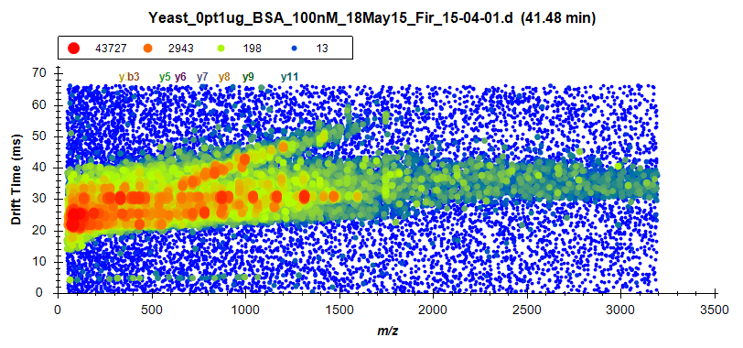

Creating an Ion Mobility Library
It should be clear now that the selectivity of chromatogram extraction in MS/MS and even MS1 can be made more selective, reducing the risk of interference from ions being targeted, by extracting from only a limited drift time range around the drift time at which the ion is expected. Like other aspects of targeted extraction, the highest confidence and selectivity is achieved when retention times and drift times as well as preferential fragment ions are known from a prior measurement and stored in libraries.
Though not described in this document, it is possible to process “All Ions” data sets which contain MS/MS fragment data with the latest version of Spectrum Mill (or PLGS for Waters data sets) with the result that the peptide spectrum matching results already are annotated with drift time and in the case of Agilent data sets, if the data file previously had a Single Field calibration applied, then also with collision cross sections.
In this tutorial, however, we will use the most broadly applicable approach of learning the drift times and collision cross section (if the data files have been Single Field calibrated) directly from the BSA standard sample and then applying it to more complex data. This is accomplished via the Use Results button in the Edit Ion Mobility Library dialog.
To create the ion mobility library for this tutorial, first remove the yeast data by doing the following:
- Close the Full-Scan window.
- From the Edit menu, click Manage Results (ctrl-R).
- Select the “Yeast_0pt1ug_BSA_100nM_18May15_Fir_15-04-01” replicate.
- Click the Remove button.
- Click the OK button.
- On the File menu, click Save (ctrl-S) to permanently remove the imported results.
And then create the library by doing the following:
- On the Settings menu, click Transition Settings.
- Click the Ion Mobility tab.
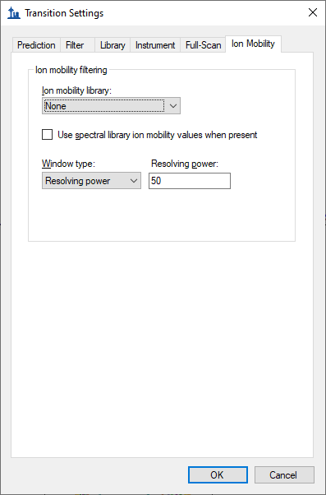
- Set the ion mobility filtering Window type to “Resolving power”.
- In the Resolving power field enter “50”.
- In the Ion mobility library dropdown list, click Add.
- In the Name field of the Edit Ion Mobility Library form that appears enter “BSA”.
- Click the Create button.
- In the File name field of the Create Ion Mobility Library form, enter “BSA” – Skyline will automatically add the extension .imsdb. (The folder should already be the IMSFiltering folder you created for this tutorial.)
- Click the Save button.
- Click the Use Results button in the Edit Ion Mobility Library form.
This starts the training process, which enumerates each peptide precursor loading the apex MS1 and MS/MS spectra just as you did manually for the charge 3 precursor of the peptide NECFLSHKDDSPDLPK. Skyline then determines the resolution width drift time range that would produce the maximum signal in the MS1 spectrum for the targeted m/z ranges. It then does the same for MS/MS and records any small shift that may separate the MS1 and MS/MS signal.
If the file contains calibration values then the library entries are recorded with a collisional cross section derived from the observed ion mobility peaks. This CCS information can later be used with other independently calibrated data files to determine the appropriate ion mobility value for filtering purposes.
When the training is complete, the form should look like this:
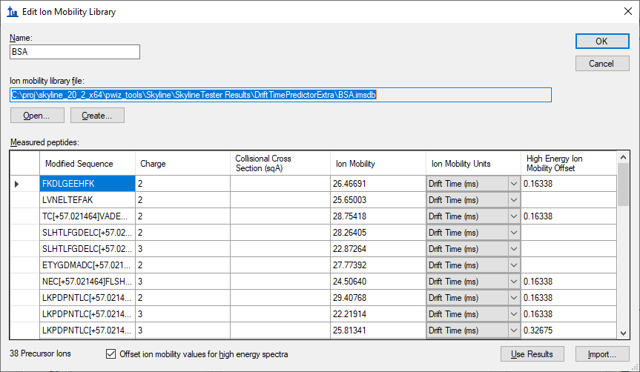
Note that the peptide NECFLSHKDDSPDLPK you have been looking at was found to yield peak intensity at 24.5064 ms, about where you would expect from the 3D spectrum plots you have examined.
Note also that the CCS column is left empty. If these data files contained calibration values, then the CCS value would have been be calculated and stored as well, allowing for calibrated drift time extraction in all results data sets. In this case, these particular files do not support CCS calibration (most do, you are unlikely to encounter this with your own ion mobility data). In this case, you will have to rely on drift time consistency between runs, which works without issue in this example.
- Click the OK button to save the ion mobility library.
Make sure your new library is selected in the Transition Settings – Ion Mobility tab. The form should look like this:
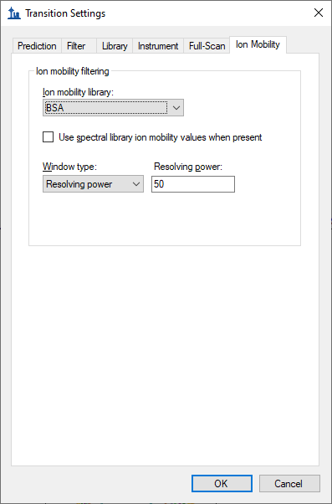
Before reimporting the yeast sample data do the following to also limit the retention time ranges for chromatogram extraction:
- Click the Full-Scan tab on the click Transition Settings form.
- Choose the Use only scans within [] minutes of predicted RT option.
- Change the number of minutes to “3” (for +/- 3 minutes or a 6-minute window)
The form should look like this:
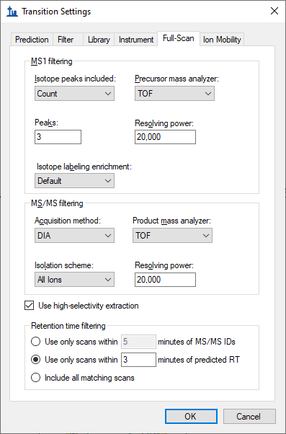
- Click the OK button.
Before reimporting the raw data, open the Peptide Settings – Prediction tab and make sure that that Use measured retention times when present is checked and the Time window field is set to “6” minutes.
- On the Settings menu, click Peptide Settings.
- Click the Prediction tab.
The form should look like this:
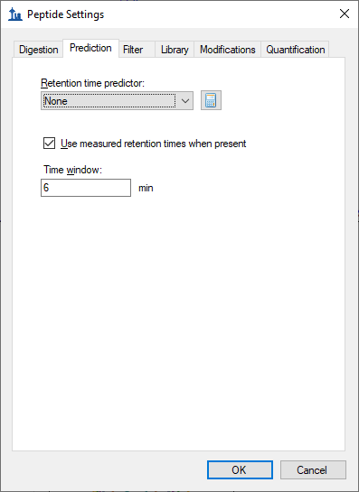
- Click the OK button.
Note that in this example we are working with MS/MS data, but it is also possible to import MS1 only ion mobility data files. In this case drift times or collisional cross section will still be used to apply a filter to MS1 spectra. Not included will be the delta drift times for fragments. With the increased signal intensity associated with MS1 data and the increased selectivity afforded by ion mobility, workflows that are focused on quantitative results may consider forgoing the inclusion of fragmentation when using ion mobility.

Reimport the Yeast Data with Ion Mobility Filtering
To reimport the yeast data, do the following:
- From the File menu, choose Import and click Results
This should bring up the following form, letting you know that retentions from existing replicates will be used in the requested chromatogram extraction and allowing you to choose which replicates:
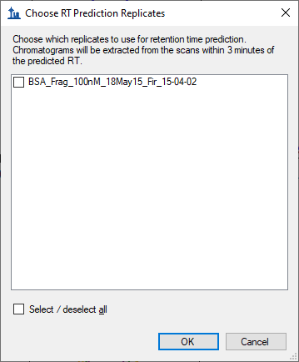
- Check Select / deselect all.
- Click the OK button.
- Click the OK button in the Import Results form.
- Select “Yeast_0pt1ug_BSA_100nM_18May15_Fir_15-04-01.d” in the Import Results Files form.
- Click the Open button.
Chromatogram extraction will begin again and you may be able to tell even just by watching the progress graph that less signal is being extracted. If you left the NECFLSHKDDSPDLPK peptide selected you will see the difference immediately:
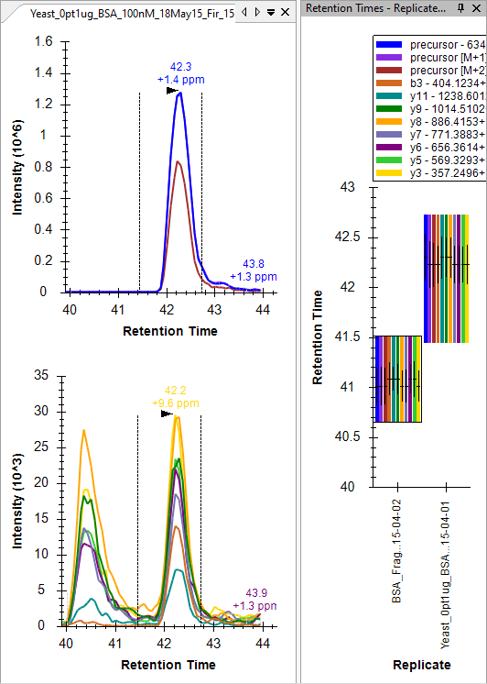
To better understand what happened, do the following:
- Click on the apex of the yellow y3 chromatogram to show the Full-Scan graph.
- Click the Zoom to Selection button in the toolbar.
The Full-Scan graph should look something like this:
You can now see the horizontal violet range showing the filter imposed by filtering with the ion mobility library you trained. Signal outside this range is now ignored by Skyline. You can also see a very light “y3” annotation just under the legend showing the location of the m/z range used to extract the chromatogram point you clicked on.
A great deal of interference has been removed from the chromatograms, and Skyline has picked the correct peak a little more than 1 minute after the peak from the water data. If you review all the peptides the picked peaks for all but the missing peptide TCVADESHAGCEK, but your note should still be there to remind you, denoted by a red triangle in the upper-right corner of the element in the Targets view.
You may have noticed some discrepancies, however, in the relative ion abundances shown in the Peak Areas plots or the dominant peak in the chromatogram plots. And, there are now peptides where interference is more obvious in the water sample than the yeast, for example the fragment ions of the first peptide in the document FKDLGEEHFK:
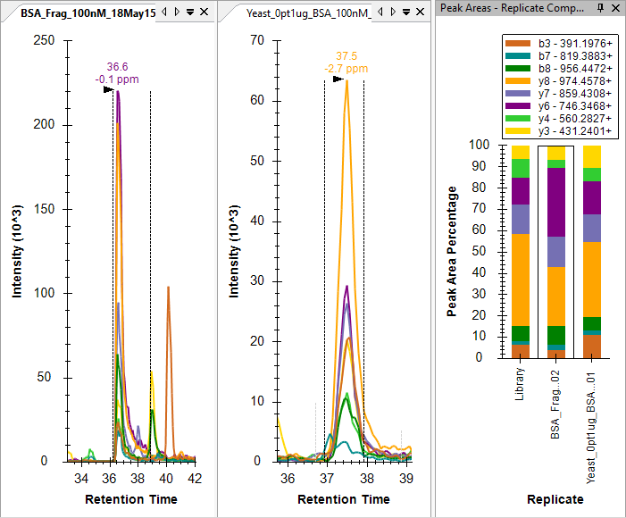
Interference that coelutes as nicely some of the chromatograms in this file could easily be coming from other charge states of the same precursor. They will have the same elution profile and may produce the same fragment ions. But, different charge states of the same peptide molecule will have different ion mobility. Even in this simple mix of BSA in water, there is also obviously interference from other potentially modified peptide forms.

Reimport the Water Data with Ion Mobility Filtering
To improve consistency between the extracted ion chromatograms of the two samples, you can now reimport the water data by doing the following:
- On the Edit menu, click Manage Results (ctrl-R).
- The water replicate “BSA_Frag_100nM_18May15_Fir_15-04-02” should already be selected.
- Click the Re-import button.
- Click the OK button.
Skyline should show the import progress form, and when the file has been reimported, you should see the chromatograms in the water sample shortened to just 6 minutes, like for yeast, and greater agreement between the two samples with greatly reduced interference in both from the original import in this tutorial.

Conclusion
In this tutorial, you have learned how to work in Skyline with mass spectrometry data with an ion mobility separation. You now understand the settings required for chromatogram extraction from this data. You have learned to interpret the alternating MS1 and MS/MS three-dimensional spectra produced by an ion mobility enabled mass spectrometer. You can now train an ion mobility library from a simplified sample for use in a more complex sample and use that library to enhance the selectivity of chromatograms extracted by Skyline. With the interactive plots in Skyline, you can now navigate and understand this highly dimensional data and you will be able to use it to improve your quantitative measurements of target ions.

